Employee Management App implementation with Collections

1. **Initial Menu**

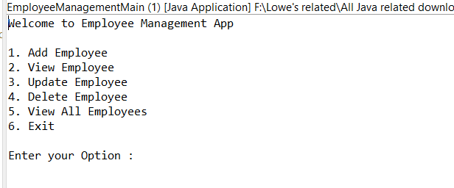

1. **View All** ---when **no records** are available

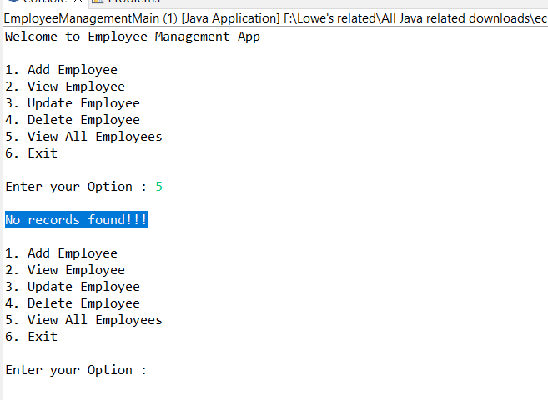

1. **Add Employee** option

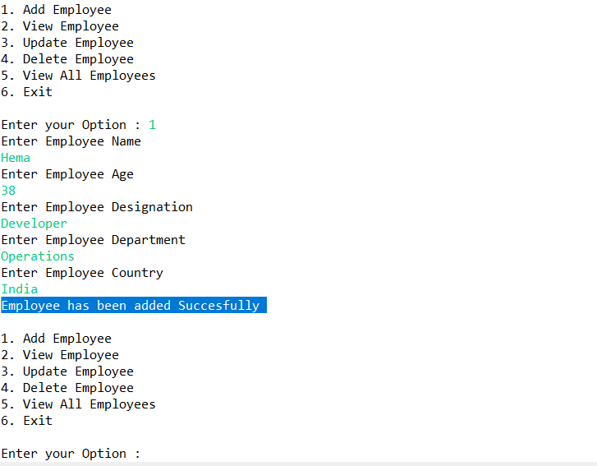

1. **View All** after adding an employee

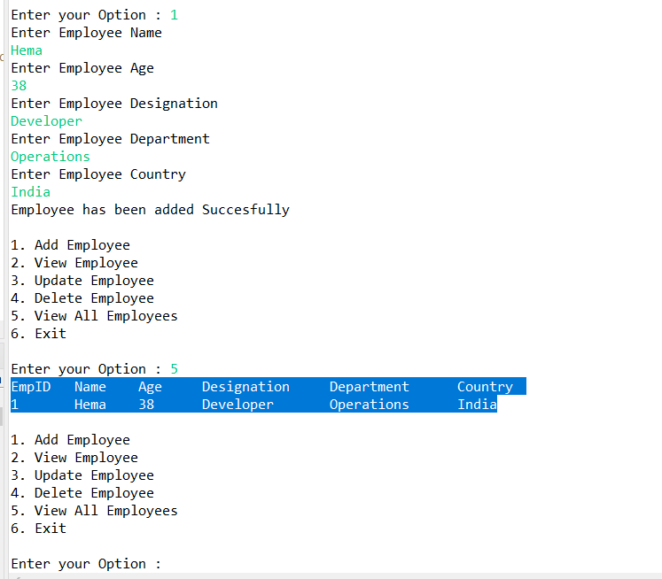

1. After **adding another employee** and V**iew All** option showing 2 records

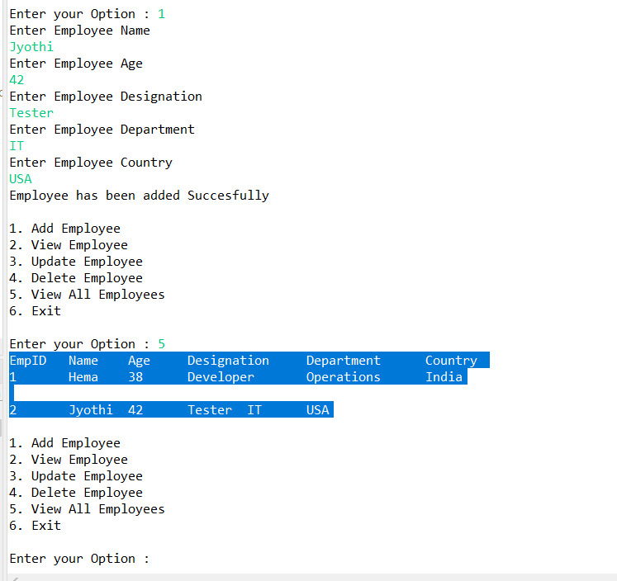

1. **Update an Employee**(with and without existing employee Id scenario)

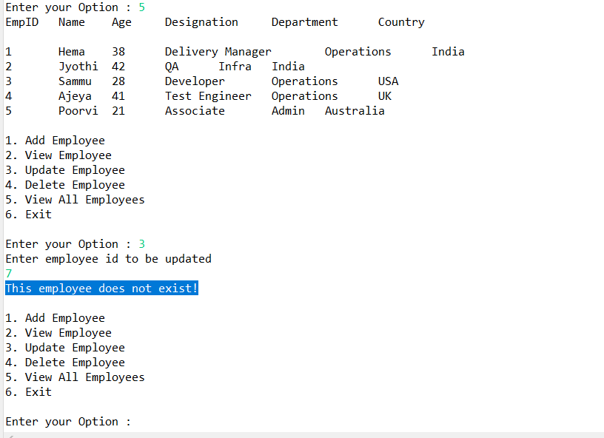

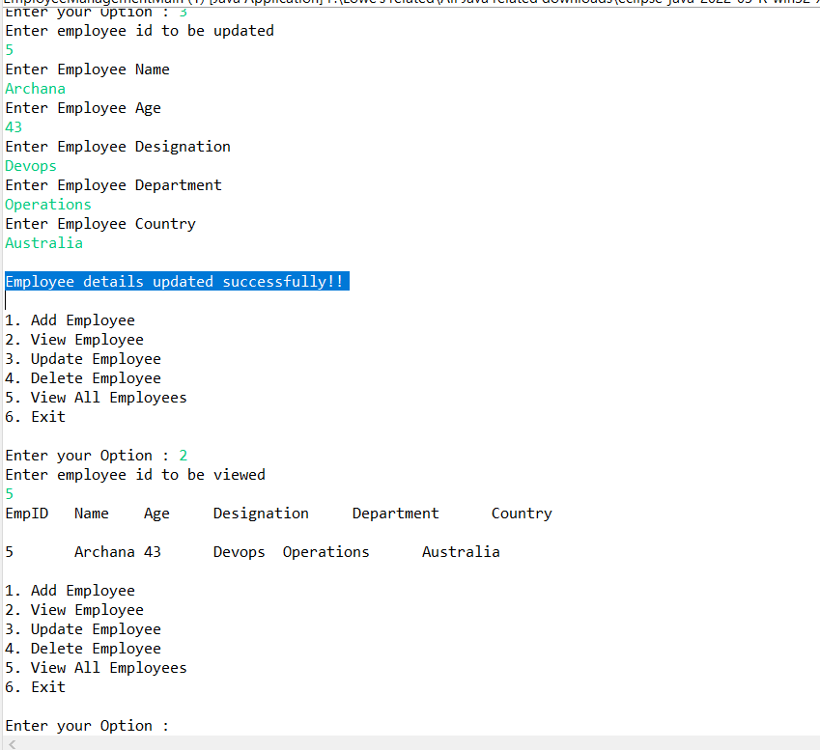

1. **View by employee ID** (the existing Id and without existing Id)

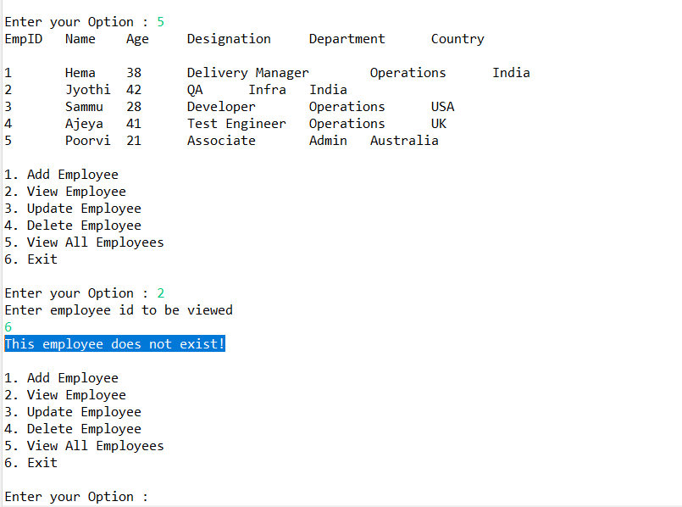

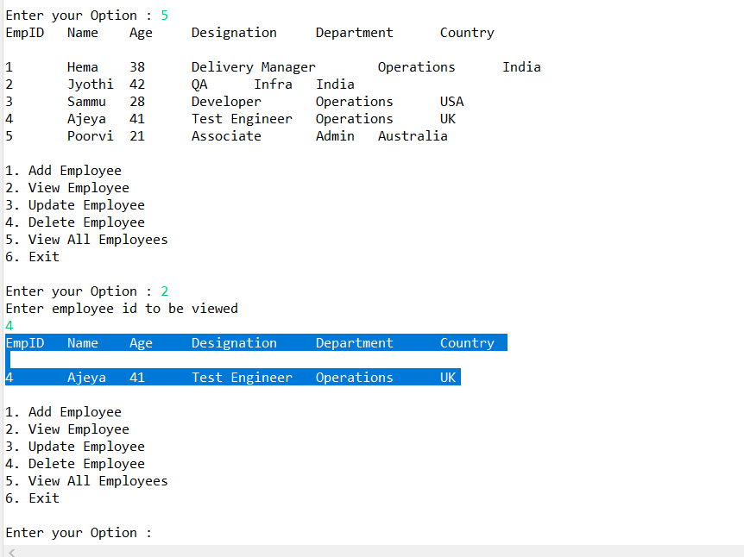

1. **Delete** an employee (by giving non existing n existing id )

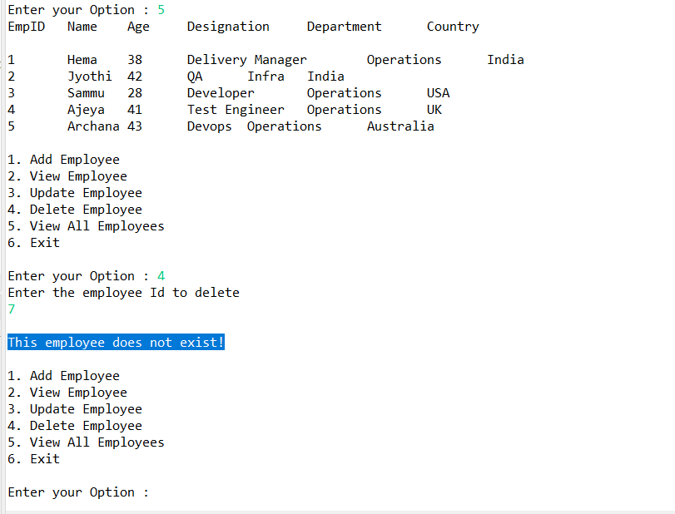

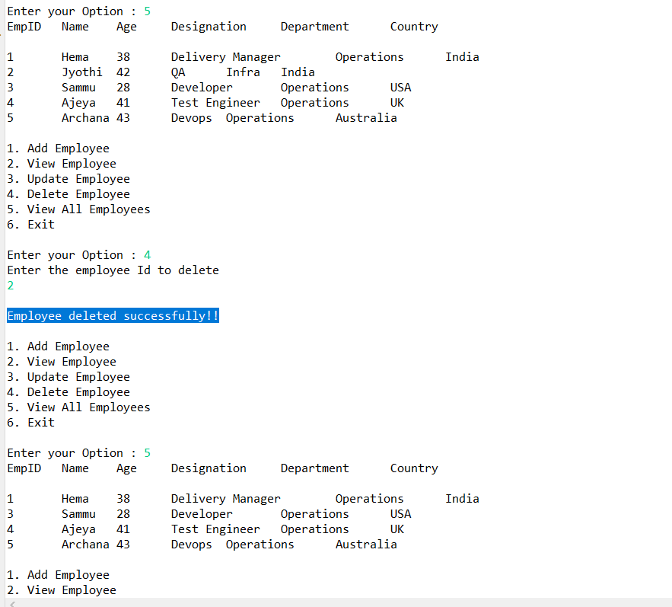

1. **Exit** option

